|  |  |
| --- | --- |
| **Practicum Case** |  |
| M0564 | ISYS6123  Introduction to Database Systems |
| **Information Systems** | **E1-ISYS6123-AM01-09** |
| ***Valid on*** *Even Semester Year 2018/2019* | **Revision 00** |

**Learning Outcomes**

* Construct query of SQL that suitable with the problem

## Topic

* Session 09 - SQL – Data Manipulation (Basic Queries 2)

## Sub Topics

* SQL Aggregate Functions
* Group By
* Having
* Compute / Compute By
* **Sub queries (IN, EXISTS, ALL, SOME)**

**Tabel Relasional**

*Relational Table*

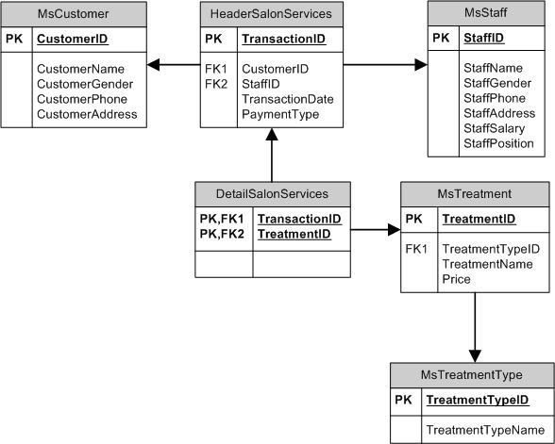

**Sintaks**

*Syntax*

###### **Alias**

**for field name**

SELECT { field_name AS field_alias | field_alias = field_name }

FROM table_name

**for table name**

SELECT { * | field_name [, …] }

FROM table_name [AS] table_alias

**for subquery name**

( SELECT { * | field_name [, …] }

FROM table_name [, …] )

[AS] table_alias

###### **In**

SELECT { * | field_name [, …] }

FROM table_name [, …]

WHERE field_name [NOT] IN ( { value1, value2 [, ...] | select_query } )

**Exists**

SELECT { * | field_name [, …] }

FROM table_name [, …]

WHERE [NOT] EXISTS (select_query)

###### **All, Any, Some**

SELECT { * | field_name [, …] }

FROM table_name [, …]

WHERE field_name { relational_operator} {ALL | ANY | SOME} ( select_query )

###### **Select Into**

SELECT { * | field_name [, …] }

INTO new_table [IN external_database]

FROM source

## Soal

*Case*

1. Display TreatmentId, and TreatmentName for every treatment which id is ‘TM001’ or ‘TM002’.

(**in**)

C:\Users\AdityaMili\Desktop\BANK SOAL\Bank Case Making\06 -\new\1.png

1. Display TreatmentName, and Price for every treatment which type is not ‘Hair Treatment’ and ‘Message / Spa’.

(**in**, **not in**)

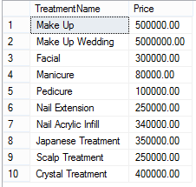

1. Display CustomerName, CustomerPhone, and CustomerAddress for every customer whose name is more than 8 charactes and did transaction on Friday.

(**len**, **in**, **datename**, **weekday**)

C:\Users\AdityaMili\Desktop\BANK SOAL\Bank Case Making\06 -\new\3.png

1. Display TreatmentTypeName, TreatmentName, and Price for every treatment that taken by customer whose name contains ‘Putra’ and happened on day 22th.

(**in**, **like**, **day**)

C:\Users\AdityaMili\Desktop\BANK SOAL\Bank Case Making\06 -\new\4.png

1. Display StaffName, CustomerName, and TransactionDate (obtained from TransactionDate in ‘Mon dd, yyyy’ format) for every treatment which the last character of treatmentid is an even number.

(**convert**, **exists**, **right**)

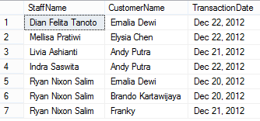

1. Display CustomerName, CustomerPhone, and CustomerAddress for every customer that was served by staff whose name’s length is an odd number.

(**exists**, **len**)

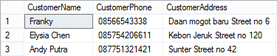

1. Display ID (obtained form last 3 characters of StaffID), and Name (obtained by taking character after the first space until character before second space in StaffName) for every staff whose name contains at least 3 words and hasn’t served male customer.

(**right**, **substring**, **charindex**, **len**, **exists**, **in**,**not like**, **like**)

C:\Users\AdityaMili\Desktop\BANK SOAL\Bank Case Making\06 -\new\7.png

1. Display TreatmentTypeName, TreatmentName, and Price for every treatment which price is higher than average of all treatment’s price.

(**alias subquery**, **avg**)

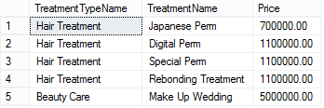

1. Display StaffName, StaffPosition, and StaffSalary for every staff with highest salary or lowest salary.

(**alias subquery**, **max**, **min**)

C:\Users\AdityaMili\Desktop\BANK SOAL\Bank Case Making\06 -\new\9.png

1. Display CustomerName, CustomerPhone, CustomerAddress, and Count Treatment (obtained from the total number of treatment) for every transaction which has the highest total number of treatment.

(**alias subquery**, **group by**, **max**, **count**)

C:\Users\AdityaMili\Desktop\BANK SOAL\Bank Case Making\06 -\new\10.png